CAREER-LIFE CONNECTIONS 12
Ms. Eng, Ms. Morabito, Ms. Neves, & Mr. Steko
https://bbycentralclc12.weebly.com/
2019 – 2020

Career-Life Connections 12 (CLC12B) is a two-credit course required by the BC Ministry of Education for Graduation. This is a mandatory but non-enrolling course which means students are responsible for attending the workshops and completing the accompanying online assignments on their own time. Workshop attendance is mandatory and will follow the dates as outlined in the workshop schedule. Students will gain meaningful and relevant insight into their personal transition to post-secondary education, the world of work, and adulthood. This course culminates in a Capstone Project.

GOALS:
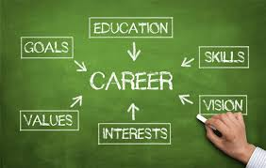
- I can recognize personal worldviews and perspectives and consider their influence on values, actions, and preferred futures
- I can reflect on experiences in school and out of school, assess development in the Core Competencies, and share highlights of their learning journey
- I can design, assemble, and present a capstone project

WORKSHOP EXPECTATIONS:

- Be respectful
- Arrive on time
- Constructive and courteous attitude
- No cellphones, air pods, and music

The course will be implemented over three workshops. Students must attend each lesson and submit the required online assignments to graduate. The CLC 12 workshops will be held on scheduled Wednesdays during FLEX time. The workshop schedule and the assignments are outlined on the CLC12 website https://bbycentralclc12.weebly.com/. Students must sign up for their workshop on the FLEX time online sign up page under Ms. Neves. Students are encouraged to see Ms. Eng, Ms. Morabito, Ms. Neves and Mr. Steko in A233 if they have any questions or need assistance with the CLC 12 course content.

